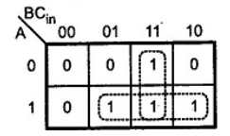
K-Map for Carry (out) K- Map for Sum
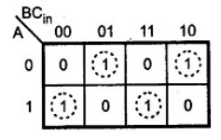

Expression from the K- Map
Sum = A’B’Cin + A’BC’in + AB’C’in + ABCin
C out = AB + ACin + BCin
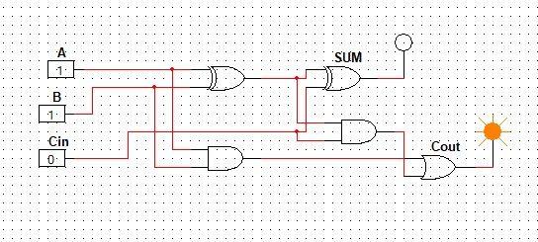
Logical diagram :-

